# Exploring Perceptions of Crime and Safety: An In-Depth Analysis of the 2017/2018 Crime Survey of England and Wales

# I. Introduction

Using univariate, bivariate, and descriptive analysis of the 2017–2018 Crime Survey for England and Wales dataset (Office for National Statistics, 2020), this research portfolio explores quantitative and qualitative analytic methodologies. Quantitative data analysis provides valuable statistical summaries and insights that can inform conclusions and recommendations (search.proquest.com, n.d.). For this portfolio, analysis of the crime survey dataset will provide an understanding of public perceptions, attitudes, and experiences related to crime and policing in England and Wales. The analysis will generate frequency distributions, cross-tabulations, and descriptive statistics on key variables in the survey (Podesva and Sharma, 2014).

By considering demographic factors and how they relate to outcome variables, it becomes possible to understand perceptual variations among groups. The quantitative analysis will ultimately assess the perceptions of fairness and effectiveness within the criminal justice system (Bowers and Robinson, 2011). This research employs the relevant quantitative methods to conduct analysis of rather complicated survey data and present those results in a meaningful fashion along with their explanations (Chiulli, 2018).

# II. Frequency Tables and Bar Charts for Categorical Demographic Variables

## Sex

The frequency table below depicts the distribution of survey respondents by sex. Of the total sample of 34,715 respondents, 16,180 (46.6%) were male and 18,535 (53.4%) were female. This indicates there were slightly more female respondents than male overall. The valid percent columns show the same percentages, confirming there were no missing values for this variable. The cumulative percent illustrates that males comprised 46.6% of the sample, while females comprised the remaining 53.4%. The sample contains a slightly higher proportion of females than males, though both sexes are well represented with a relatively even split in this large nationwide survey.

***Table 1: Frequency table for sex***

|  |  |  |  |  |  |
| --- | --- | --- | --- | --- | --- |
| Sex | | | | | |
|  | | Frequency | Percent | Valid Percent | Cumulative Percent |
| Valid | Male | 16180 | 46.6 | 46.6 | 46.6 |
| Female | 18535 | 53.4 | 53.4 | 100.0 |
| Total | 34715 | 100.0 | 100.0 |  |

***Chart 1: Frequency Distribution of sex***

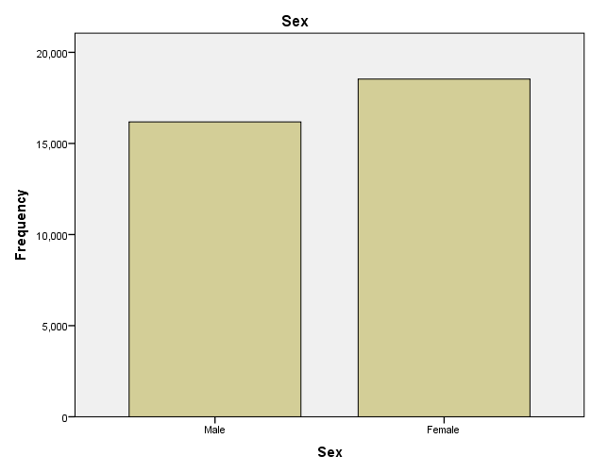

1. **Marital Status**

The provided marital status frequency table shows that 15,880 respondents, or 45.8% of the sample, were married or in a civil partnership, making up the majority of the respondents. The next biggest group was single respondents at 22.4%, followed by cohabiting at 10.3%. Smaller groups included divorced or legally dissolved partnerships (8.8%), widowed (9.7%), and separated (2.9%). Together, the married and cohabiting groups make up over half the sample at 56.2%. The cumulative percent shows the distribution across categories, with married respondents making up the first 45.8%, singles comprising the next 22.4%, and so on. Only 67 respondents (.2%) were missing data for marital status. Overall, the sample contains a diversity of marital statuses, reflecting the makeup of the wider population. Marital status is an important demographic factor that may influence perceptions and experiences related to crime and policing (Boateng, 2016: 2891). Comparing across groups could reveal differing views or impacts by relationship status.

***Table 2: Marital status frequency table***

|  |  |  |  |  |  |
| --- | --- | --- | --- | --- | --- |
| Marital status | | | | | |
|  | | Frequency | Percent | Valid Percent | Cumulative Percent |
| Valid | Married/civil partnered | 15880 | 45.7 | 45.8 | 45.8 |
| Cohabiting | 3578 | 10.3 | 10.3 | 56.2 |
| Single | 7765 | 22.4 | 22.4 | 78.6 |
| Separated | 1005 | 2.9 | 2.9 | 81.5 |
| Divorced/Legally dissolved partnership | 3056 | 8.8 | 8.8 | 90.3 |
| Widowed | 3364 | 9.7 | 9.7 | 100.0 |
| Total | 34648 | 99.8 | 100.0 |  |
| Missing | Not classified | 67 | .2 |  |  |
| Total | | 34715 | 100.0 |  |  |

***Chart 2: Marital status Frequency distribution***

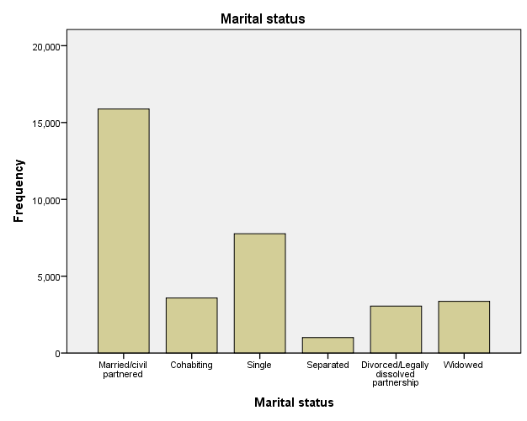

1. **Economic Status**

The economic status frequency table shows paid work was the most common status, with 18,990 respondents (54.8%). Retired was the next biggest group with 10,009 (28.9%), followed by looking after family/home at 4.7%. All other categories were less than 5% of the sample each. The cumulative percent demonstrates that over half (54.8%) were in paid work, rising to 70% when retired respondents are included. Only 36 cases (.1%) were missing in the dataset. The sample reflects a range of economic statuses, with a slight majority employed or retired. Economic status may relate to vulnerability or exposure to certain crime types (Al-Anizy, 2022).

***Table 3: Frequency table for Economic status***

|  |  |  |  |  |  |
| --- | --- | --- | --- | --- | --- |
| Economic status | | | | | |
|  | | Frequency | Percent | Valid Percent | Cumulative Percent |
| Valid | Paid work | 18990 | 54.7 | 54.8 | 54.8 |
| Government training scheme | 31 | .1 | .1 | 54.8 |
| Away from job/waiting to take job up | 711 | 2.0 | 2.1 | 56.9 |
| Unpaid work | 163 | .5 | .5 | 57.4 |
| Looking for work | 548 | 1.6 | 1.6 | 58.9 |
| Student | 742 | 2.1 | 2.1 | 61.1 |
| Looking after family/home | 1615 | 4.7 | 4.7 | 65.7 |
| Temporarily sick/ill | 136 | .4 | .4 | 66.1 |
| Long-term sick/ill | 1340 | 3.9 | 3.9 | 70.0 |
| Retired | 10009 | 28.8 | 28.9 | 98.9 |
| Other | 394 | 1.1 | 1.1 | 100.0 |
| Total | 34679 | 99.9 | 100.0 |  |
| Missing | Not classified | 36 | .1 |  |  |
| Total | | 34715 | 100.0 |  |  |

***Chart 3: Economic status distribution***

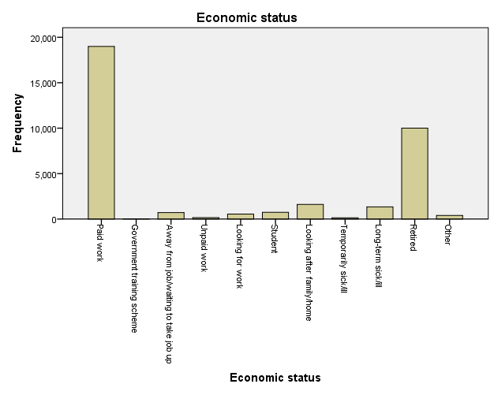

# III. Gender Differences in Feelings of Safety Walking After Dark

The cross-tabulation analysis between respondent sex and feelings of safety walking alone after dark indicates some notable differences between males and females. Within the valid sample of 8,230 respondents, females were more likely to report feeling very unsafe walking alone at night, with 501 females selecting this compared to just 114 males. In contrast, males were more likely to say they would feel very or fairly safe walking alone after dark (1828 and 1509 respectively for males; 993 and 1801 for females). This suggests that females generally feel less safe than males when walking alone at night. The differences may reflect heightened concerns among women about risks like sexual assault or other attacks when unaccompanied (Roberts, 2019:30). Feelings of vulnerability could restrict women's movements and activities during nighttime hours.

|  |  |  |  |  |  |  |
| --- | --- | --- | --- | --- | --- | --- |
| Sex * How safe do you feel walking alone in this area after dark Crosstabulation | | | | | | |
| Count | | | | | | |
|  | | How safe do you feel walking alone in this area after dark | | | | Total |
| Very safe | Fairly safe | A bit unsafe | Very unsafe |
| Sex | Male | 1828 | 1509 | 391 | 114 | 3842 |
| Female | 993 | 1801 | 1093 | 501 | 4388 |
| Total | | 2821 | 3310 | 1484 | 615 | 8230 |

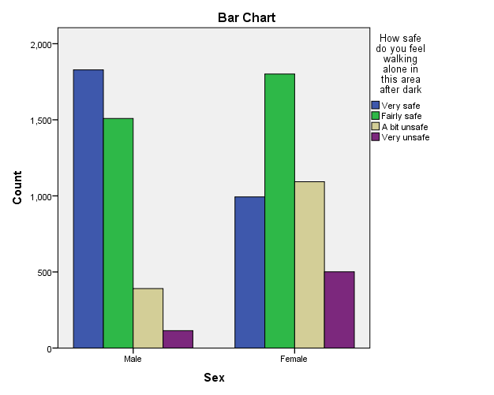

**IV. Relationship Between Gross Income and Worries About Home Security**

The cross-tabulation shows some association between higher household income and lower worries about home break-ins. For instance, of respondents with income over £80,000, 70 reported being "not very worried" compared to just 6 who were "very worried." The pattern is reversed for lower incomes, with more respondents reporting being "very worried" in the lower brackets. However, the relationship is not entirely linear, with some fluctuation across middle income bands. The small subsample may impact reliability. Overall, though, higher income appears loosely tied to lower worries, perhaps reflecting ability to afford better home security systems. Lower income households may feel more vulnerable due to lack of protections (Holzmann and Jørgensen, 2001). Further analysis on a bigger subsample could provide more detail on the income-worry relationship. Additional factors like prior victimization could also intersect with income in shaping worry.

|  |  |  |  |  |  |  |
| --- | --- | --- | --- | --- | --- | --- |
| Which is the gross income of the household * How worried about having your home broken into Crosstabulation | | | | | | |
| Count | | | | | | |
|  | | How worried about having your home broken into | | | | Total |
| Very worried | Fairly worried | Not very worried | Not at all worried |
| Which is the gross income of the household | A under £5,000 | 0 | 0 | 4 | 1 | 5 |
| B £5,000 - £9,999 | 1 | 3 | 3 | 2 | 9 |
| C £10,000 - £14,999 | 3 | 9 | 15 | 10 | 37 |
| D £15,000 - £19,999 | 8 | 14 | 30 | 5 | 57 |
| E £20,000 - £24,999 | 7 | 11 | 29 | 10 | 57 |
| F £25,000 - £29,999 | 6 | 13 | 28 | 6 | 53 |
| G £30,000 - £34,999 | 5 | 9 | 23 | 11 | 48 |
| H £35,000 - £39,999 | 9 | 11 | 27 | 6 | 53 |
| I £40,000 - £44,999 | 4 | 8 | 31 | 10 | 53 |
| J £45,000 - £49,999 | 3 | 19 | 22 | 8 | 52 |
| K £50,000 - £59,999 | 4 | 21 | 21 | 11 | 57 |
| L £60,000 - £69,999 | 4 | 15 | 34 | 7 | 60 |
| M £70,000 - £79,999 | 4 | 10 | 35 | 7 | 56 |
| N £80,000 or over | 6 | 41 | 70 | 19 | 136 |
| Total | | 64 | 184 | 372 | 113 | 733 |

**Task 4: Distribution of Composite Scale Variables**

The Worry scale measuring concerns about victimization shows a mean of -.03, quite close to the scale midpoint of 0. The small negative mean indicates worries leaning slightly lower. However, the standard deviation of .99 demonstrates a wide spread of responses. The Confidence in police scale has a similar mean of -.02 and standard deviation of 1.0. The averages near the midpoint and large standard deviations show most responses are clustered towards the center of both scales, with fewer very high or low values. This represents a relatively normal distribution. However, the Confidence scale shows a slightly positive skew based on a higher maximum value. Overall, most respondents report moderate worry and confidence levels, with less polarization at the scale extremes. Comparing the means shows worries about victimization are aligned with but slightly lower than police confidence on average.

# Conclusion

In conclusion, this quantitative analysis of the 2017/2018 Crime Survey for England and Wales provided valuable insights into public perceptions of crime and policing. The frequency distributions showed the demographic makeup, and the cross-tabulations showed that the groups' anxieties and concerns about safety differed. Average levels of worry and confidence were found to be positive when composite scale variables were examined. The analysis techniques enabled a data-driven exploration of crime attitudes and experiences in the total population. Qualitative research can complement the quantitative survey analysis by providing more in-depth understanding of people's perspectives. Generally, combining quantitative descriptives with qualitative inquiry can build a comprehensive evidence base to inform police policy and improve community relations and also help reduce crime rates. This research portfolio demonstrated the utilization of univariate, bivariate and descriptive statistical analysis and summarizing of the 2017–2018 Crime Survey for England and Wales dataset.

# List of references:

Al-Anizy, M.S. (2022) *Effects of family’s economic situation on crime rates*. <https://resmilitaris.net/menu-script/index.php/resmilitaris/article/view/1319>.

Almquist, Ylva B, Kvart, Signild and Brännström, Lars (2020). A practical guide to quantitative methods with SPSS. *figshare*. [online] DOI: <https://doi.org/10.17045/sthlmuni.10321829.v2>

Almquist, Ylva B, Kvart, Signild and Brännström, Lars (2020). A practical guide to quantitative methods with SPSS. *figshare*. [online] Doi: <https://doi.org/10.17045/sthlmuni.10321829.v2>.

Bellitto, M. and Coccia, M. (2018). *Interrelationships Between Violent Crime, Demographic and Socioeconomic Factors: A Preliminary Analysis Between Central-Northern European Countries and Mediterranean Countries*. [online] papers.ssrn.com. Available at: https://papers.ssrn.com/sol3/papers.cfm?abstract_id=3275310 [Accessed 27 Apr. 2023].

Boateng, F.D. (2016) 'Crime reporting behavior: Do attitudes toward the police matter?,' *Journal of Interpersonal Violence*, 33(18), pp. 2891–2916. <https://doi.org/10.1177/0886260516632356>.

Bowers, J. and Robinson, P.H. (2011) 'Perceptions of Fairness and Justice: The Shared Aims & Occasional Conflicts of Legitimacy and Moral Credibility,' *Social Science Research Network* [Preprint]. <https://doi.org/10.2139/ssrn.1814006>.

Chiulli, R.M. (2018) *Quantitative analysis*, *Routledge eBooks*. <https://doi.org/10.1201/9780203741559>.

‌Gover, A.R. *et al.* (2011) 'An exploratory study on perceptions of safety, fear of crime, and victimization experiences among faculty and staff at an urban university: a focus on gender,' *Criminal Justice Studies*, 24(1), pp. 37–55. <https://doi.org/10.1080/1478601x.2011.544193>.

Holzmann, R. and Jørgensen, S., 2001. Social risk management: A new conceptual framework for social protection, and beyond. *International Tax and Public Finance*, *8*, pp.529-556.

Office for National Statistics. (2020). *Crime Survey for England and Wales, 2015-2016*. [data collection]. *2nd Edition.*UK Data Service. SN: 8140, [DOI: http://doi.org/10.5255/UKDA-SN-8140-2](http://doi.org/10.5255/UKDA-SN-8140-2)

Podesva, R.J. and Sharma, D. (2014). *Research Methods in Linguistics*. [online] *Google Books*. Cambridge University Press. Available at: https://books.google.com/books?hl=en&lr=&id=eeRRAgAAQBAJ&oi=fnd&pg=PA288&dq=requency+distributions [Accessed 9 Jan. 2024].

*Presenting Your Data with SPSS Explained* (no date). <https://books.google.com/books?hl=en&lr=&id=QggqDwAAQBAJ&oi=fnd&pg=PP1&dq=analysing+Demographic+Variables+spss&ots=CKVIS-cHq8&sig=SY95owjC2m_2ujv31p0EmdPIN6c>.

Roberts, N. (2019) 'Gender, sexual danger and the everyday management of risks: the social control of young females,' *Journal of Gender-based Violence*, 3(1), pp. 29–43. <https://doi.org/10.1332/239868018x15265563342670>.

Roll, S., Taylor, S. and Grinstein-Weiss, M. (n.d.). *Financial Anxiety in Low-and Moderate-Income Households: Findings from the Household Financial Survey*. [online] Available at: <https://openscholarship.wustl.edu/cgi/viewcontent.cgi?article=1596&context=csd_research>.

search.proquest.com. (n.d.). *Quantitative data analysis for social scientists - ProQuest*. [online] Available at: <https://search.proquest.com/openview/71ba8781f88a269938b860d448e6e8d2/1?pq-origsite=gscholar&cbl=1818083>.

‌